### CONSTRUCTION Materials

1. Match the words with the pictures:

|  |  |  |  |
| --- | --- | --- | --- |
| Glazed Units | Sand | Stone | Lime |
| Timber | Concrete Blocks | Brick | Gravel |
| Rubble | Ceramic Tiles | Pebbles | Steel Rods |
| Tarmac | Chipboard | Cladding | Cement |
|  | | | |
|  |  |  |  |
|  |  |  |  |
|  |  |  |  |
|  |  |  |  |

### Which of the materials above could you use to describe the construction of this SEGRO logistics centre in The Netherlands?

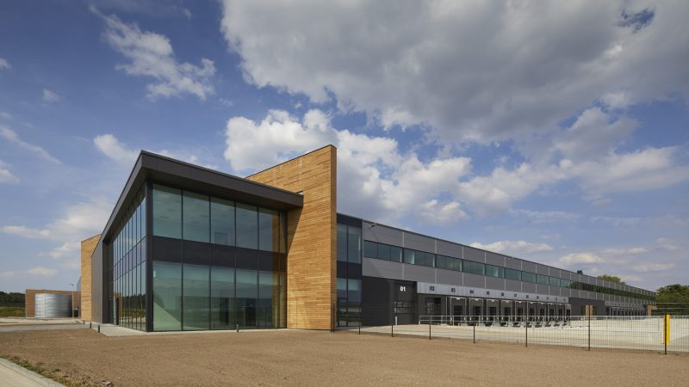

### Discussion:

### What is the SEGRO policy on the sourcing of construction materials? (Quality, origin, etc.)

### What challenges does the Company face in the supply and cost of materials?

### How does SEGRO ensure that it meets its own sustainainability guidelines? (BREEAM, ESG)

|  |  |  |  |
| --- | --- | --- | --- |
| Answers to Exercise 1 | | | |
|  | | | |
|  |  |  |  |
|  |  |  |  |
|  |  |  |  |
|  |  |  |  |