### TalKING ABOUT BUILDING SPECIFICATIONs

|  |
| --- |
| 1. Describing dimensions  Look at the different ways we can talk about the dimensions of a warehouse:    1. The **height** of the eaves is 10 metres. The eaves are 10 metres **high**.    2. The **width** of the building is 25 metres. The building is 25 metres **wide**.    3. The **length** of the interior bay is 12 metres. The interior bay is 12 metres **long**.    4. The **weight** of each steel rafter is 2 tonnes. Each steel rafter **weighs** 2 tonnes.    5. The **floor** **area** of the warehouse is 25 metres **by** 30 metres. The floor area is **750 m2**.    6. The **distance between** each rafter is 10m. There is a 10m **gap between** each rafter.    7. The **angle** of the roof slope is 7.9 degrees. The roof slope is **angled at** 7.9 degrees. |

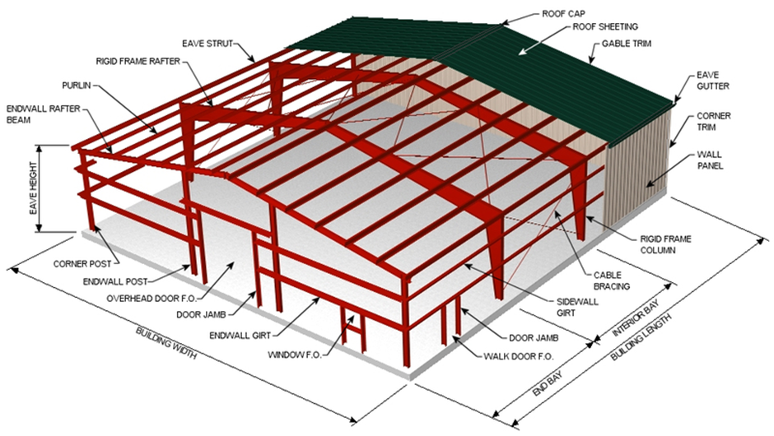

10m

12m

30m

25m

|  |
| --- |
| 1. Choose one of the drawings below and write your own sentences to describe the dimensions of the building in a similar way. |
| **PDF] Design of steel portal frame buildings for fire safety | Semantic  ScholarDrawing One** |
| Buy Wholesale China Economic Prefab Solar Panel Steel Structure Warehouse  Buildings House Design Plan & Warehouse at USD 20 | Global Sources  **Drawing Two** |

|  |  |
| --- | --- |
| I have chosen: *(mark an ‘x’ in one box)*   * Drawing One  * Drawing Two | |
|  |  |
|  |  |
|  |  |
|  |  |
|  |  |
|  |  |
|  |  |

|  |  |
| --- | --- |
| 1. Describing structural components.  Match the two halves of the sentences. The first one has been done for you. | |
| The warehouse has a raised floor | **coated with** grey primer. |
| The steel frame was | **clad in** composite steel cladding. |
| The front elevation was | **laid** at the back of the warehouse. |
| The rafters were | **covered in** metal roof sheeting. |
| Low energy tarmac was | **separates** the offices from the loading bays. |
| LED lighting was | **fixed to** the exterior roof. |
| Cable bracing was | **installed in** the ceiling. |
| A mezzanine | **divided into** office and storage space. |
| Photovoltaic panels were | **used to secure** the steel frame. |
| The warehouse was | **constructed of** precast concrete planks. |

|  |  |  |  |  |
| --- | --- | --- | --- | --- |
| 1. Fill in the boxes below with the most appropriate word: | | | | |
| Screwed | Suspended | Cladded | Protected | Chained |
| Bolted | Taped | Soldered | Supported | Welded |

|  |  |
| --- | --- |
| **1** | **2** |
| from | from |
| **3** | **4** |
| by | around |
|   **5** | **6** |
| together | with |

|  |  |
| --- | --- |
| **Advantages and disadvantages of welding as a joining method - Forgeway Ltd**  **7** | **8** |
| to | to |
| **9** | **10** |
| to | to |

|  |  |
| --- | --- |
| **Answers to Exercise 3:** | |
| The warehouse has a raised floor | **constructed of** precast concrete planks. |
| The steel frame was | **coated with** grey primer. |
| The front elevation was | **clad in** composite steel cladding. |
| The rafters were | **covered in** metal roof sheeting. |
| Low energy tarmac was | **laid** at the back of the warehouse. |
| LED lighting was | **installed in** the ceiling. |
| Cable bracing was | **used to secure** the steel frame. |
| A mezzanine | **separates** the offices from the loading bays. |
| Photovoltaic panels were | **fixed to** the exterior roof. |
| The warehouse was | **divided into** office and storage space. |

|  |  |
| --- | --- |
| **Answers to Exercise 4:** | |
| 1 | Protected from …  As in: ‘Hard hats **protected** the workers **from** falling masonry’. |
| 2 | Suspended from …  As in: ‘The false ceiling was **suspended** **from** the rafters’. |
| 3 | Supported by …  As in: ‘The old building was **supported** **by** rigid steelwork’. |
| 4 | Taped around …  As in: ‘The workers **taped** **around** the unguarded ventilation opening’. |
| 5 | Chained to …  As in: ‘The equipment was **chained** **together** to prevent theft’. |
| 6 | Cladded with …  As in: ‘The building was **cladded** **with** non-combustible aluminium sheets’. |
| 7 | Welded to …  As in: ‘The strut was **welded** **to** the main steel girder’. |
| 8 | Soldered to …  As in: ‘The wire was **soldered** **to** the circuit board.’ |
| 9 | Bolted to …  As in: ‘The strut was **bolted** **to** the rafter’. |
| 10 | Screwed to …  As in: ‘The shelf bracket was **screwed** **to** the wall’. |